**Install Docker on Ubuntu Using Default Repositories**

**Step 1: Update Software Repositories**

It’s a good idea to update the local database of software to make sure you’ve got access to the latest revisions.

Open a terminal window and type:

sudo apt-get update

Allow the operation to complete.

**Step 2: Uninstall Old Versions of Docker**

Next, it’s recommended to uninstall any old Docker software before proceeding.

Use the command:

sudo apt-get remove docker docker-engine docker.io

**Step 3: Install Docker on Ubuntu 18.04**

To install Docker on Ubuntu, in the terminal window enter the command:

sudo apt install docker.io

**Step 4: Start and Automate Docker**

The Docker service needs to be setup to run at startup. To do so, type in each command followed by enter:

sudo systemctl start docker

sudo systemctl enable docker

### Step 5 (Optional): Check Docker Version

To verify the installed Docker version number, enter:

docker --version

<https://www.digitalocean.com/community/tutorials/how-to-install-and-use-docker-on-ubuntu-18-04>

sudo docker images

I azure portal

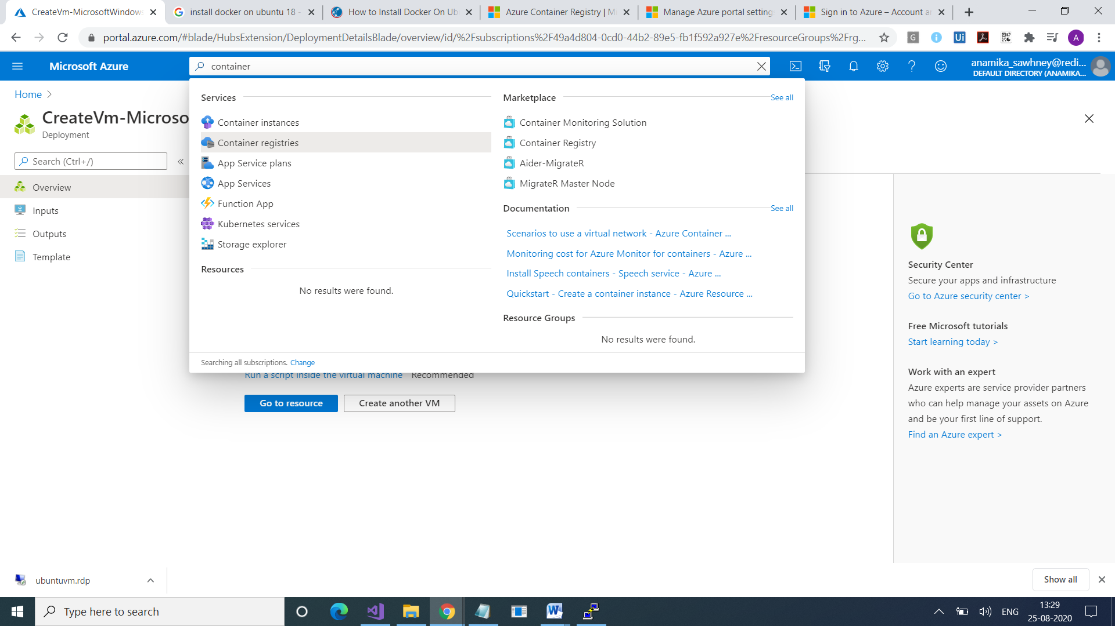

Use this link

<https://docs.microsoft.com/en-us/cli/azure/install-azure-cli-apt?view=azure-cli-latest>

anamika@ubuntuvm:~$ sudo systemctl start docker

anamika@ubuntuvm:~$ sudo systemctl enable docker

anamika@ubuntuvm:~$ docker --version

Docker version 19.03.6, build 369ce74a3c

anamika@ubuntuvm:~$ clear

anamika@ubuntuvm:~$ sudo docker images

REPOSITORY TAG IMAGE ID CREATED SIZE

anamika@ubuntuvm:~$ sudo apt-get install ca-certificates curl apt-transport-https lsb-release gnupg

Reading package lists... Done

anamika@ubuntuvm:~$ curl -sL https://packages.microsoft.com/keys/microsoft.asc |

> gpg --dearmor |

> sudo tee /etc/apt/trusted.gpg.d/microsoft.gpg > /dev/null

anamika@ubuntuvm:~$ AZ_REPO=$(lsb_release -cs)

anamika@ubuntuvm:~$ echo "deb [arch=amd64] https://packages.microsoft.com/repos/azure-cli/ $AZ_REPO main" |

> sudo tee /etc/apt/sources.list.d/azure-cli.list

deb [arch=amd64] https://packages.microsoft.com/repos/azure-cli/ bionic main

anamika@ubuntuvm:~$ sudo apt-get update

anamika@ubuntuvm:~$ sudo apt-get install azure-cli

anamika@ubuntuvm:~$ az login

To sign in, use a web browser to open the page https://microsoft.com/devicelogin and enter the code APXW2VEPZ to authenticate.

anamika@ubuntuvm:~$ sudo apt-get install apache2

anamika@ubuntuvm:~$ sudo az acr login --name ubuntu123

Login Succeeded

anamika@ubuntuvm:~$ sudo docker pull hello-world

anamika@ubuntuvm:~$ sudo docker tag hello-world ubuntu123.azurecr.io/hello-world:v1

anamika@ubuntuvm:~$ sudo docker push ubuntu123.azurecr.io/hello-world:v1

anamika@ubuntuvm:~$ sudo docker run ubuntu123.azurecr.io/hello-world:v1

Hello from Docker!

$ docker run -it ubuntu bash

anamika@ubuntuvm:~$

Docker Cheat Sheet
Build
Build an image from the Dockerﬁle in the
current directory and tag the image 
docker build -t myi...

Create Ubuntu VM

Install docker

create conteinar

docker container run -d --help

docker container run –d –name test-container –p 81:80 nginx

docler container ls

Chek on browser

Ip :81

Image is coming from docker hub

Now put this images in azure CR

Gi to portal openAzure container register

Go to repositories

It is blank right now

Go to AccessKeys

Take suername , password

Go yto vm with ocker

Docker login server name

Now our VM is regsiterd with this ACR

Go to goohgle

Azure container registery docker command to oush 9mages

Create tahe tag

Doker tag nginx path /saomple/nginx

Socler imahes ls

Now push this image to containr

Socker push nginx path /saomple/nginx

Docker container rm –f trest-contaoner

Docker container ls

Dicker images ls

Dockr image rm –f image id image id

Docker pull complete path

Now createcontainer fro9m this image

Docker continare run –d –name name –p 8089: 80 complete srver name

Again check in browser with 8089 port no.